

NAME: RUTUJA SUNIL KHARODE
REG.NO: 25BCE10605
PROJECT TITLE: VEHICLE SERVICE HISTORY
MANAGEMENT
SUBJECT: INTRODUCTION TO PROBLEM
SOLVING AND PROGRAMMING
CODE: CSE1021
DATE OF SUBMISSION: 25 NOV 2025

INTRODUCTION

Vehicles need regular servicing to stay safe and run smoothly, but many service centres still struggle to keep proper records of a vehicle’s service history. Most of the time, the details are written on loose papers or stored in a small booklet, which often gets lost, torn, or damaged. Because of this, owners usually forget what work was done earlier or when the last service actually happened.

To fix this issue, the Vehicle Service History Management System has been developed. It provides an easy, digital way to store and check all service details in one place. Instead of relying on paper, the system lets users save important information like the service date, type of work done, amount spent, and parts that were replaced.

Overall, this system helps people maintain proper records, avoid confusion, and plan their future servicing better. It’s a simple and practical solution for keeping vehicle service information organized and easily accessible.

PROBLEM STATEMENT

Many vehicle owners struggle to keep track of their service details because everything is usually written on paper bills or kept separately by different service centres. These papers can easily get misplaced, torn, or damaged, and as time passes, owners forget what repairs were done or when the last service actually happened. This often creates confusion and sometimes even leads to missed or delayed maintenance.

Because of this, there is a real need for a simple and organized system where all service-related information can be stored in one place. Such a system would make it much easier for owners to check their vehicle’s service history whenever they need it.

FUNCTIONAL REQUIREMENTS

MODULE-1: Data Management
- When the program starts, it should automatically check if the service history file exists.
- If the file is available, the system should load all the service records into memory so the user can work with them.
- If no file exists, the program should simply start with an empty list.
- Any time record is added or updated, the system should save all the records into the CSV file.
- The file should contain the following details: Vehicle number, Service Date, Service Type, Service Cost and Remarks

MODULE-2: Service Record Operations
- The system must allow the user to add a new service entry.
- The user should be able to type in the vehicle number, service type, service date, cost and remark.
- Once the record is added, the system should save it immediately and show a success message.
- The user should be able to view all the stored service records.
- If no record exists, the system should display clear message saying that no data is available.
- The system should let the user search for service history based on a vehicle number.
- It should display all matching records. If no matching vehicle number is found, the system should inform the user.
MODULE-3: User Interaction and Menu Workflow
- The system should display a clear menu with these options:
a. Add Service Record
b. View all Records
c. Search Records
d. Exit
- Based on what user selects, the system should perform the correct operation.
- If the user enters something invalid, it should show an error message.
- When the user selects the exit option, the system should close the program after showing a goodbye message.

WORK-FLOW
Start Program
↓
Load existing records from file
↓
Show Main Menu
↓
User chooses an option
↓
Option 1: Add Record → Save to file → Back to menu
Option 2: View Records → Show records → Back to menu
Option 3: Search Record → Display result → Back to menu
Option 4: Exit → End Program
NON-FUNCTIONAL REQUIREMENTS

- Performance
- The system should respond quickly to user input.
- Loading, saving, searching and viewing records should happen within seconds.
- The program should handle basic CSV operations smoothly without slowing down.

- Usability
- The menu and prompts should be easy to understand for the new user.
- All instructions should be simple and clear so that even someone with no technical background can use the system.
- Error messages should explain what went wrong.

- Reliability
- The system should work consistently every time it is used.
- All service record must be properly saved to CSV file so that no data is lost.
- The program should load records correctly every time it starts.

- Maintainability
- The code should be simple easy to use in future.
- If new features need to be added later, such as editing or deleting records, they should be easy to include.
- The program structure should remain easy for beginners to understand.

- Error Handling
- The system must handle incorrect or empty user inputs gradually.
- I f the user inputs something invalid, the program should show a clear message instead of crashing.
- The system should continue running normally after an error.

- Security
- Only basic, safe file operations are used, so the system should not allow access to any files other than the CSV.
- The program should avoid exposing sensitive information and only store simple service details.

- Scalability
- The system should be able to handle a growing number of service records in the CSV file.
- Even if the number of records becomes larger, users should still be able to search and view them without any issue.

TECHNICAL EXPECTATIONS

- Architectural Design
For this project, I used simple architecture, I divided the program into small parts so that each part handles only one job.
- One part deals with reading and writing CSV file.
- Another part handles all the operations like adding, viewing or searching records.
- The last part handles the main menu and user inputs.
This makes the program easier to manage and improve later.

- Use of Basic Concepts
I used basic programming concepts that I learned in class:
- For searching, I used a simple linear search, which means checking each record one by one.
- To store data, I used a list of dictionaries. Each dictionary holds one service record.
- I also used the CSV module in python to save and load data.
- The program uses basic things like loops, conditions and functions to keep everything organized.

- Modular and Clean Implementation
I tried to write the program in a modular way. Instead of putting everything inside one big block of code. I created different functions such as:
- load_from()
- save_to_file()
- add_record()
- view_all_records()
- search_record()
- main()
Each function does only one task, which makes the code easier
to read and update.

- Documentation and Comments
I added single comments in the code explaining what each function does. Since I’m still learning, I kept the comments basic so anyone who reads the code will understand what is happening. I also used clear variable means so the code becomes easier to follow.

- Validation and error handling
I added basic checks so the program doesn’t crash if the user enters something wrong.
- If the user enters a wrong menu choice, the program shows a message and asks again.
- If no record is found during search, it tells the user clearly.
- If the CSV file doesn’t exist at the start, the program simply creates an empty list instead of crashing.

- Using Git for Version Control
Even though this is a small project, I used git to keep track of my changes. I used simple commands like:
- git init
- git add .
- git commit -m “First version”
This helped me save different versions of my code so I could go
back if something went wrong.

- Folder Structure
I created a simple folder structure so that everything stays organized.

VehicleServiceProject/
│
├── main.py
├── vehicle_service_history.csv
├── README.md
└── tests/
└── test_records.py

SYSTEM ARCHITECTURE

The Vehicle Service History Management System follows a straightforward architecture that makes it easy to understand and maintain. The idea is to keep things simple while still implementing all the essential components needed for basic data management.
Main Components:
- User Interface Layer (Console Menu)
  - Shows options
  - Accepts user input
  - Displays results
- Processing Layer (Functions)
  - add_record()
  - view_all_records()
  - search_record()
These handle the main logic of the system.
- Data Storage Layer (CSV File)
  - Stores all service records
  - Easily readable and editable
When the program starts, it first loads the data from the CSV file (if it exists). The user interacts with the menu to perform actions. Based on the user's choice, the appropriate function runs and uses the data storage layer to read or write data. This layered architecture keeps the project clean and organized.
DESIGN DIAGRAMS

- Use Case Diagram

User
/ | \
/ | \
/ | \
(Add Record) (View Records) (Search Records)

- Workflow Diagram

Start
↓
Load records from CSV
↓
Show Main Menu
↓
User selects option
↓
1. Add Record
2. View Records
3. Search Record
4. Exit
↓
Perform action
↓
Return to Menu
- Sequence Diagram

user → system: start program
system → file: load records
user → system: choose option
system → user: perform operation
system → file: save (if needed)
user → system: exit

- Class/Component Diagram

VehicleServiceSystem

load_from_file()
save_to_file()
add_record()
view_all_records()
search_record()
main()

- ER Diagram

Service_Record

Vehicle_Number (Primary Key*)
Service_Date
Service_Type
Service_Cost
Remarks

DESIGN DECISIONS AND RATIONALE

- CSV file was chosen because it is simple and does not require database setup.
- Functions were used extensively to promote modularity.
- Menu-based navigation makes the system intuitive for beginners.
- No external libraries other than csv and os were used.
- Dictionary-based rows make data more readable and manageable.

IMPLEMENTATION & RATIONALE

This project uses a single Python file containing multiple functions. Each function handles one part of the system:
- load_from_file() → reads CSV
- save_to_file() → writes CSV
- add_record() → takes user input & appends record
- view_all_records() → displays all entries
- search_record() → searches records by vehicle number
- main() → loops menu and connects all pieces
The code is cleanly commented so everyone can understand it without any difficulty.

SCREENSHOTS/RESULTS
Python Code:
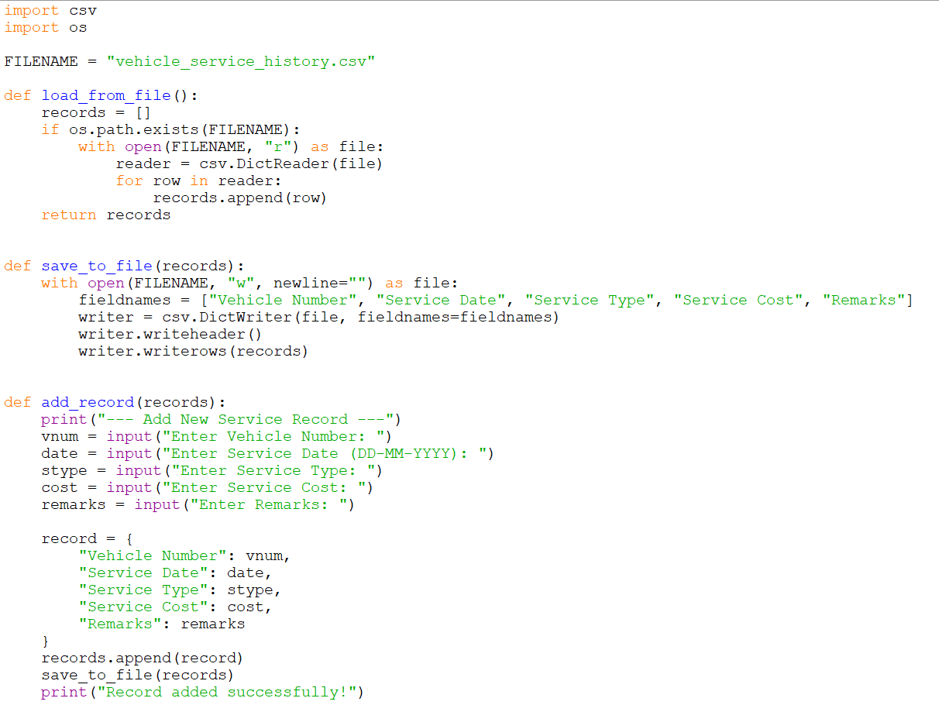
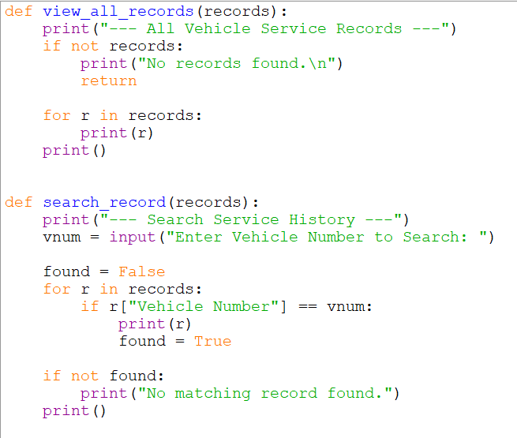
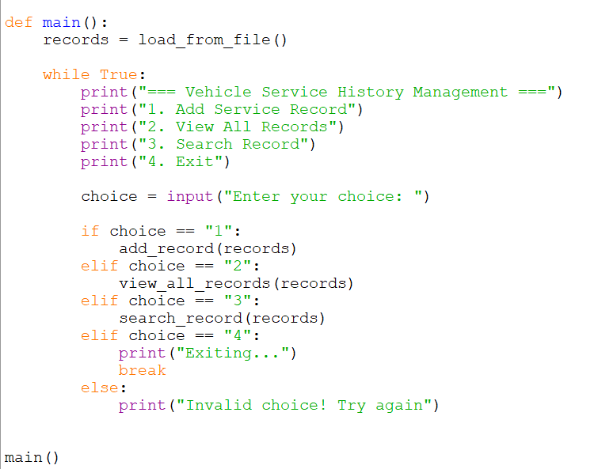

Output:

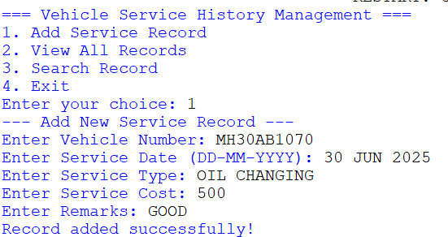
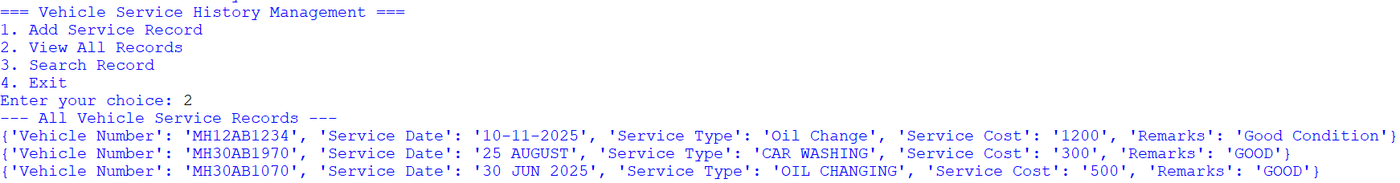
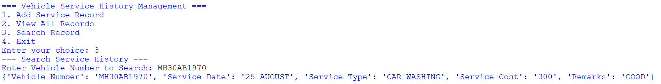
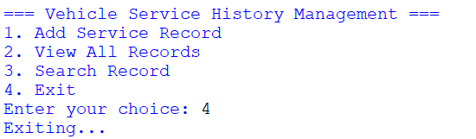

TESTING APPROACH

The system was manually tested using:
- Valid inputs
- Invalid menu options
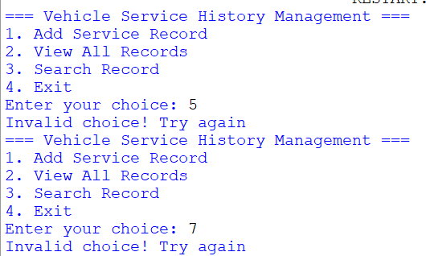
- Searching non-existing vehicles
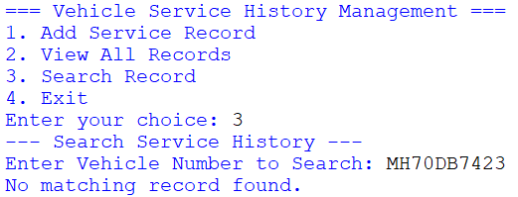

- Adding multiple records
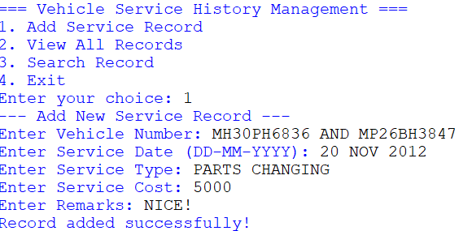
- Viewing empty records
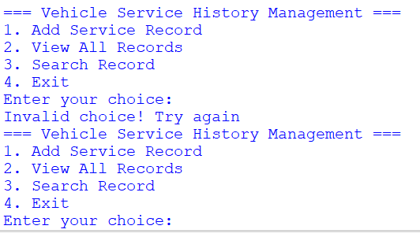
- Viewing after adding
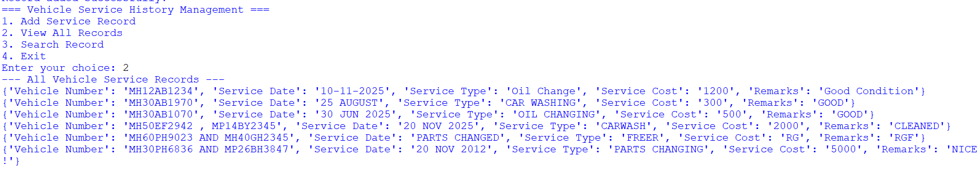
All major functions worked as expected during testing.

CHALLENGES FACED

As a beginner, a few challenges were encountered:
- Understanding how to store data permanently
- Figuring out how to read and write CSV files properly
- Managing the loop for the menu
- Structuring the code into functions instead of writing everything in one block
Overcoming these challenges helped greatly in learning practical Python.

LEARNINGS & KEY TAKEAWAYS

Through this project, I learned:
- How to handle real-world data
- How to work with CSV files in Python
- The importance of modular code
- Basics of data storage and file handling
- How to design and structure a small software system
- The value of diagrams for explaining a project
This project strengthened my confidence in writing complete programs independently.

FUTURE ENHANCEMENTS

In the future, this system can be improved by:
- Adding a GUI interface
- Using a proper database like SQLite
- Sending service reminders
- Adding report generation (PDF or Excel)
- Allowing multiple vehicles per user
- Adding backup and restore options

REFERENCES

Python Official Documentation
W3Schools Python Tutorials
Stack Overflow Code Examples
Class Lecture Notes

